User Guide for Players

Background
We provide various online services to racquet clubs and sports clubs globally under the domain names listed below. Aside from a few read-only pages (accessible via the club links section on our home page) you will be required to login using in order to use the system. Your club generally decides who is allowed to use the system and manages the list of user accounts.
Our software is currently available on the following domains. For simplicity we will refer to it as clubmanager.ie for the remainder of this document.
- www.clubmanager.ie
- www.clubcourts.co.uk
- www.myclubcourts.com
- www.leaguesladders.com
- www.myclubmanager.co.nz
In the cases where we have provided a themed version of the website for your club, this will be available via a subdomain as advised by your club. Examples include:
- http://www.westwood.clubmanager.ie
- http://www.ttc.clubcourts.co.uk

1 - User Accounts

1.1 Login
In most cases you will receive your username and password via email. You can enter these on any of public pages in the text boxes at the top of the page (see screenshot below).
Login details are generally provided as your club is set up, from existing club membership records. If you join a club that is already using our system then they will generally add an account for you. You may need to chase this with the administrators at your club.
If you haven’t received login details, generally one of the following has happened.
- Your club did not include you on the list or forgot to create an account for you
- Your club has setup an account with an incorrect email address for you
- The account was setup and we emailed you your login details but:
  - they were blocked by your spam filter or email provider, OR
  - you deleted them without realising what they were
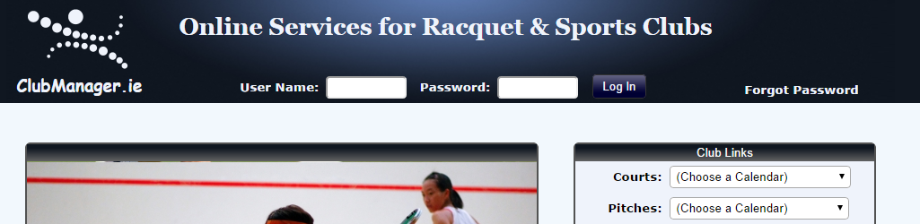

1.2 Forgot password
If you forget your password simply click the “Forgot Password” link in the top right of the home page, as per the screenshot above. Choose to fill in either your username or the email address that was used when your account was created, and click the appropriate submit button. We will then email you with login details.
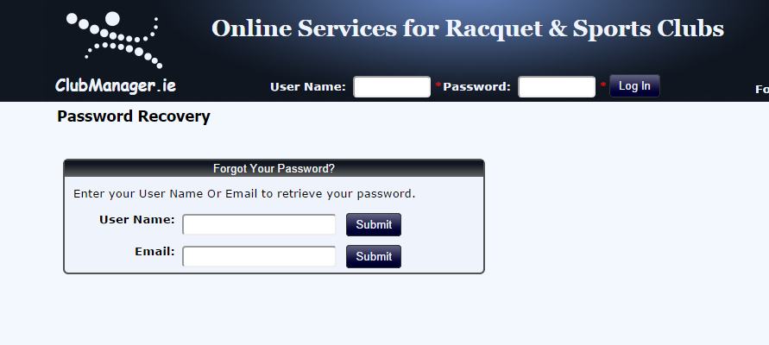

1.2 Forgot username / Need a user account
In the event you have forgotten your username or if you need a user account, you can “Contact Your Club” using the link in the footer, or via other contact information you have for them. They will then send out full login details.
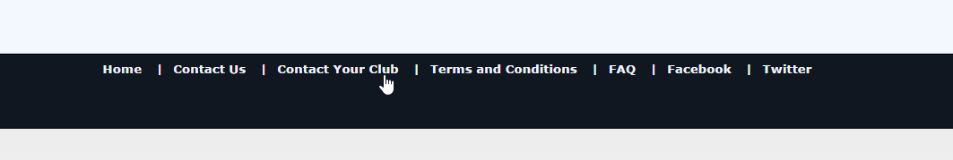

1.3 Locked Accounts
If you, or somebody using your username, tries to login with an incorrect password 5 times, your account will become locked. A self-recovery process will then kick in, sending a password recovery email to the email address associated with that account.
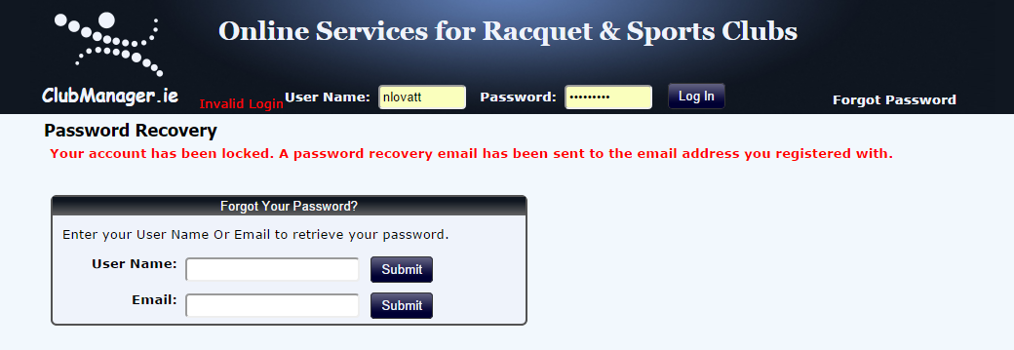
The link in that email will bring you to the page below, where you can set a new password.
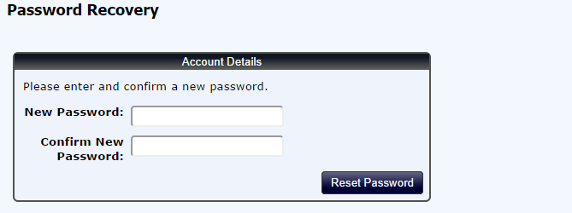

1.4 Self Signup (Only where supported by your club)
Some clubs choose to allow players to self-sign up to use the online system. In such cases, the link to the sign up page is either provided on the club website, or available via an email from the contact in your club. Simply click the link and fill in the form on that page: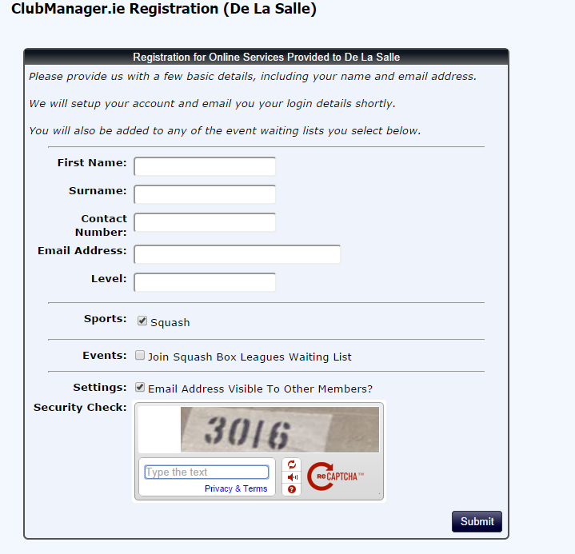

2 – The Basics

2.1 Navigation / Sport Selection
Once you are logged in, a number of menu options will appear in line with the modules and services your club (and possibly its coaches) are using. All of the appropriate pages are available via the menu system. If your club has more than one sport, and you have more than one sport subscription, you will have a dropdown box in the top right of your screen allowing you to set the context sport for the logged in session.

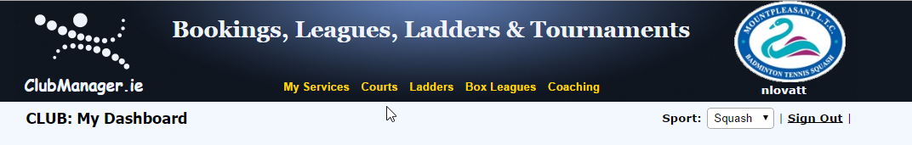

2.2 My Dashboard
The dashboard is a summary page, and is usually the default landing page after login (unless your club has requested an alternate landing page). Depending on club subscriptions, it shows a row of activity from any singles ladders and box leagues you are involved in. At the bottom right is a summary of any upcoming court bookings, and bottom left is a players list which you can use to locate other players and get their contact information.

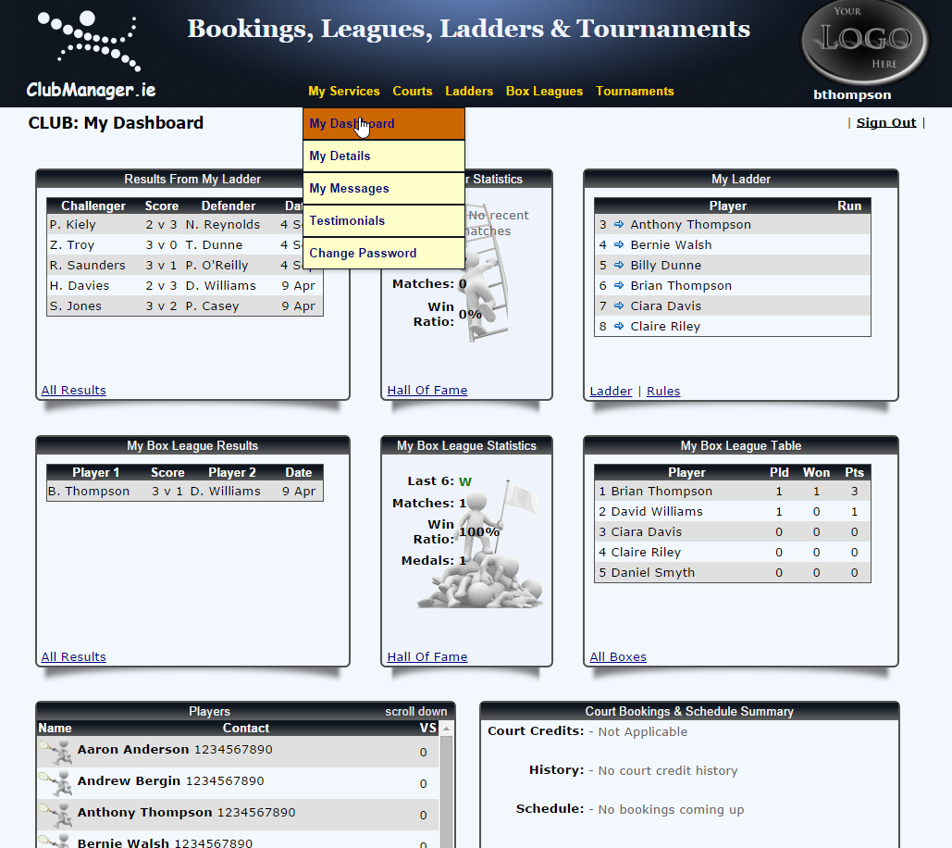

2.3 My Details
You can edit your details under “My Services / My Details”. Options include setting a contact number, changing your email address, and setting your default sport for future logins. 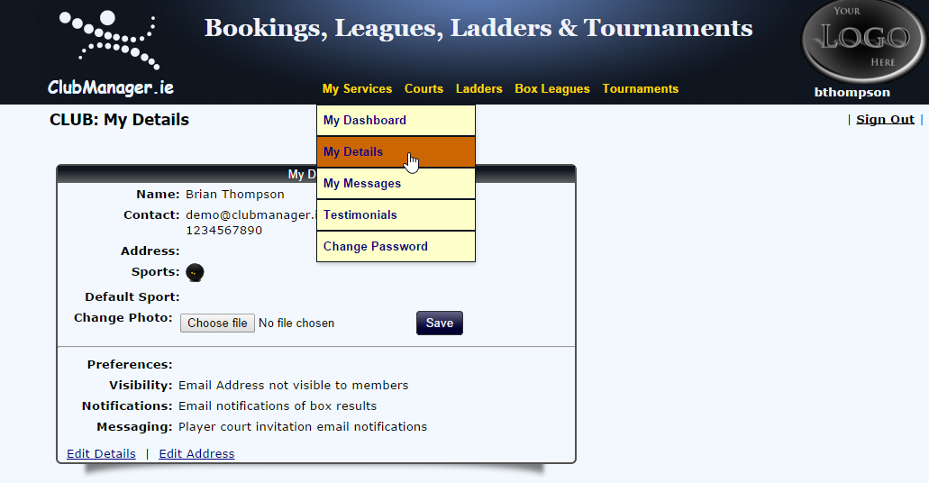

3 - Court Booking
Once logged in, user in clubs we provided court booking services to will have the ability to book, update and cancel courts via the courts menu:
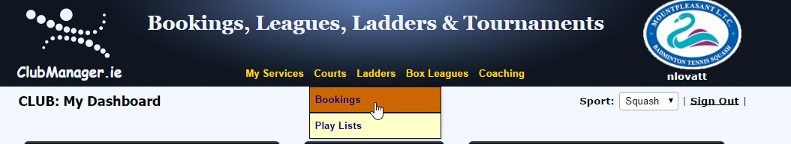

Rules: Familiarize with the rules for your club by clicking on the rules icon
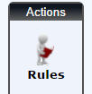

3.1 Book a court
Once on the courts page, choose the date in the filters section by clicking on the text to pop open the calendar control, or using the arrow buttons:
Default View:
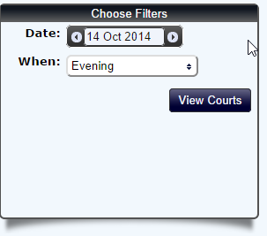
Handy Date Picker:
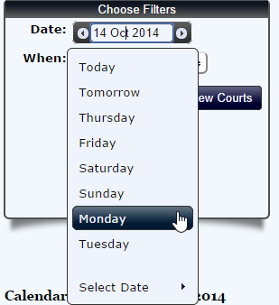
Full Calendar:
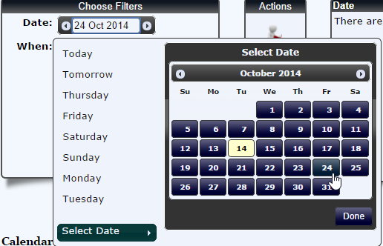

Once you have the appropriate day selected, click an available slot in the calendar:
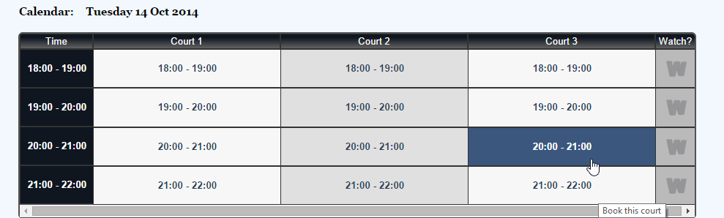

Then confirm the booking details before clicking the book button:
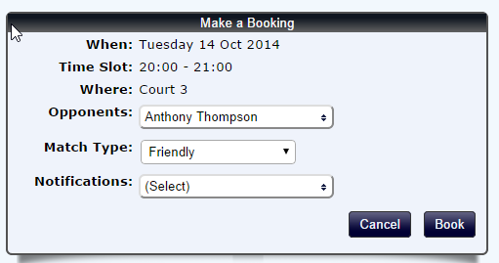
Opponents: Anybody involved in the booking. Some clubs require one or more opponents to be specified in a booking. Each will receive a confirmation email for the booking.
Match Type: Ladder match, friendly, box league match etc. This is secondary information for the booking. The software will try and match it to a known fixture, allowing a date to be displayed in the fixture details.
Notifications: Use this section to invite players from your box or your custom play list to join the match that requires additional players. Note that some clubs require a minimum number of players per booking which may render this feature obsolete.

3.2 Edit / Cancel / Notify a booking
Each booking made appears in a list in the top right of the page. You can click the icons to cancel, edit or notify.
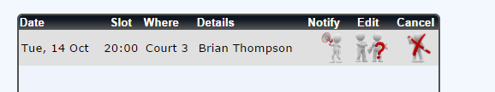

Cancel: Removes the booking and refunds any court credits due (check the rules for the refundable window)
Edit: Used to change the players involved. An update email will be sent to all parties, added, removed or remaining involved.
Notify: Can be used to invite players from your box or your custom play list to join the match.

3.3 Playlists / Inviting Players
Unless your club requires all players to be named at time of booking, you have the option to create a playlist and invite those players to take part in a match you are organising on a first come first serve basis. Locate the “Play Lists” menu option under “Courts” as follows:
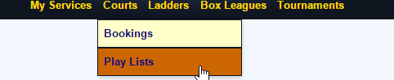
Then simply select the players you would like to have on your play list, and click update:
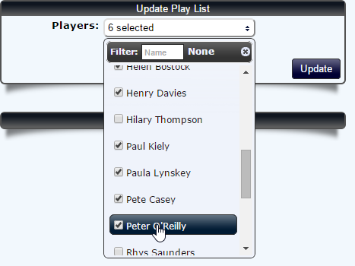

On the court bookings page, choose your court slot and select “My Play List” from the Notification options:

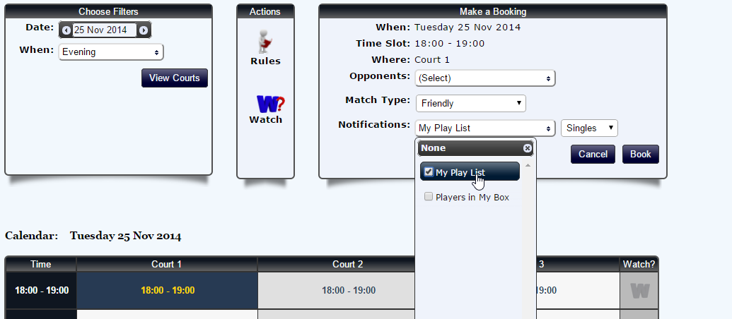

If you are invited to take part in a match you will receive an email like this this:

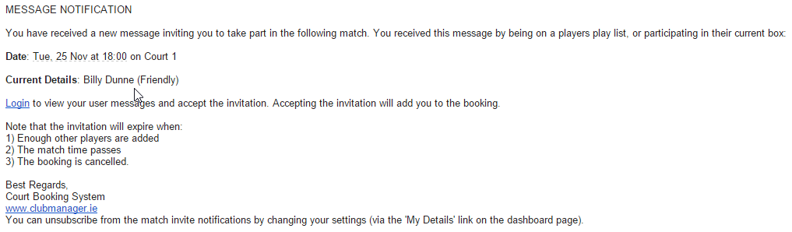

3.4 Accepting an Invitation
Following on from the previous sections, you can accept an invitation by logging into the site. You should see a speech bubble next to the sign out link indicating that you have a new message.

Click that and you will a pop out message asking you to accept or reject the invitation:

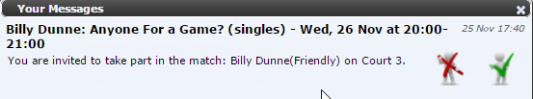
If you accepted, the match will now appear in your schedule and you will receive a confirmation email.
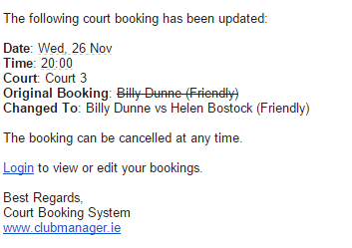
You can also accept / decline on the messages page via “My Messages” under the “My Services” menu option:
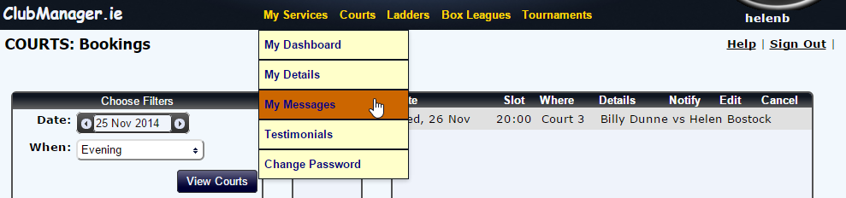

4 - Box Leagues
Once logged in, user in clubs we provided box leagues services to will have the ability to view positions and tables, and enter results for matches they are involved in, via the box leagues menu:
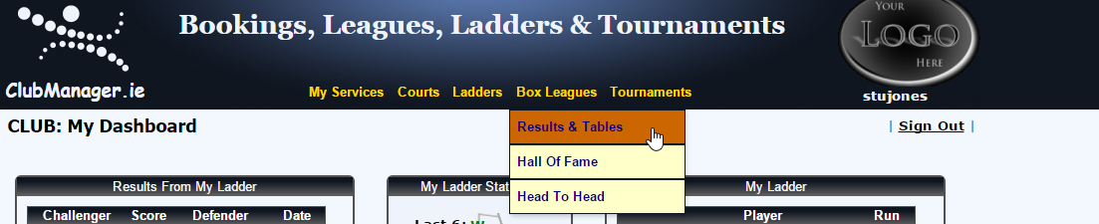

4.1 Entering Results (Standard Singles Mode)
As the page loads, the positions can be seen on the left hand side, and the results on the right. You move the mouse icon over the positions table the appropriate results will scroll up alongside.
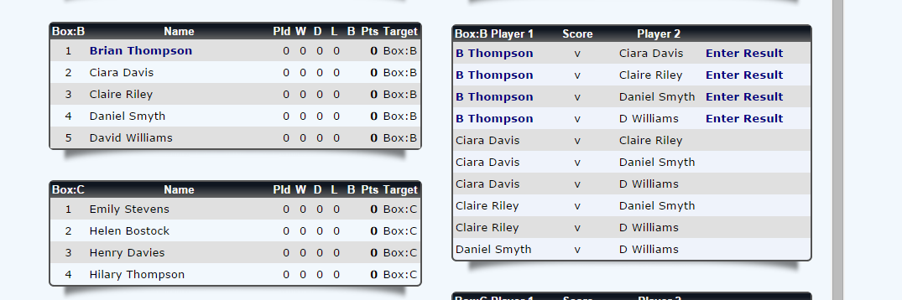

Click on “Enter Result” for the appropriate match. A form will pop out:
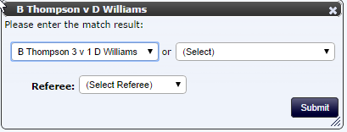
Select the appropriate score/result and click submit. Note that for some sports you can also select the sub scores. So a 2-1 in tennis might have sub scores of 6-4, 3-6 and 6-2. The alternative box contains special scores such as walkovers. The list of scores options is managed by each club.
Once you click submit, the score is entered. The points are re-calculated and the positions are updated as follows:
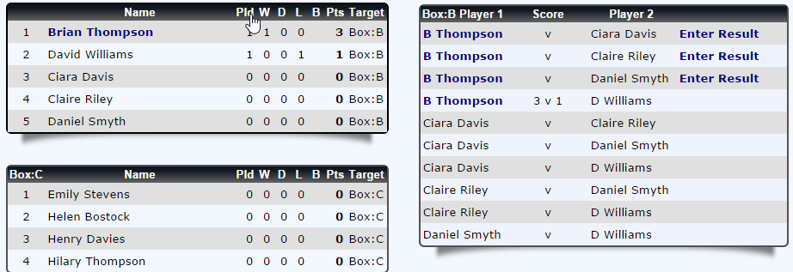

5 - Ladders
Once logged in, user in clubs we provided challenge ladder services to will have the ability to view ladder positions and results They can issue challenges and subsequently enter results for matches they are involved in, via the ladders menu:
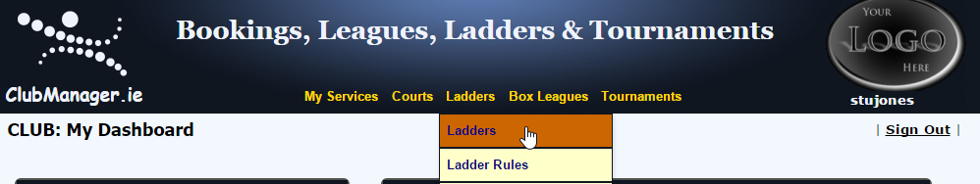

5.1 Issue a Challenge (Standard Singles Mode)
As the page loads, the ladder (positions) can be seen on the left hand side. The existing challenged and latest results are located on the right. Locate yourself on the ladder. In the example below Stuart Jones is in 17th place on the ladder, and has the option of challenging up to three places above him by clicking the sport icon next to the player name.
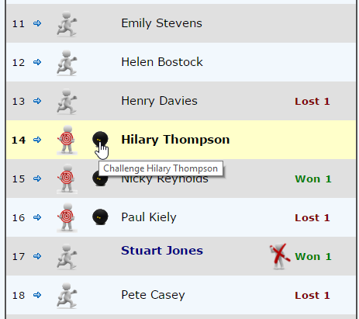
Once the challenge is issued, it appears in the challenges list and an email is sent out to both players. The players become locked in that challenge and cannot challenge or be challenged by others until the match is resolved.
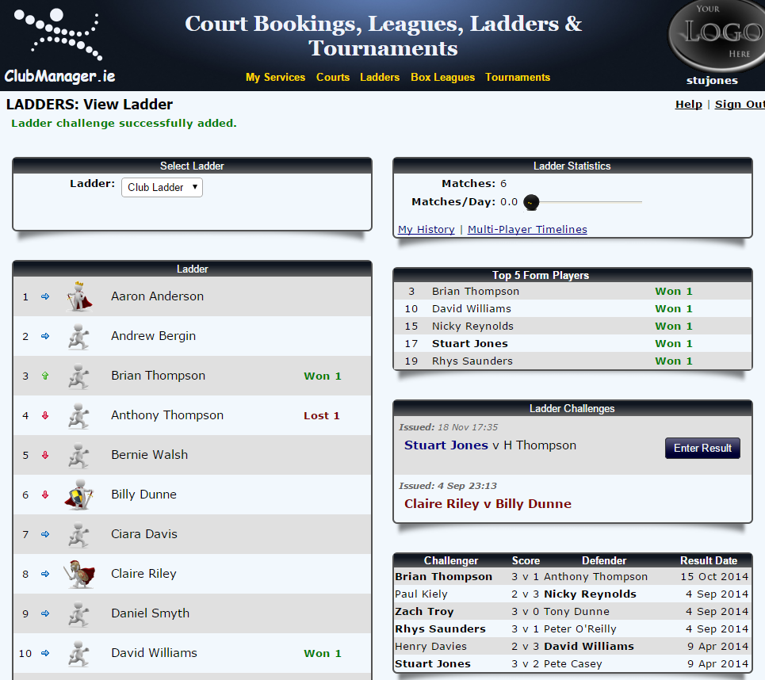

The email looks like this, and may be customised by your club:
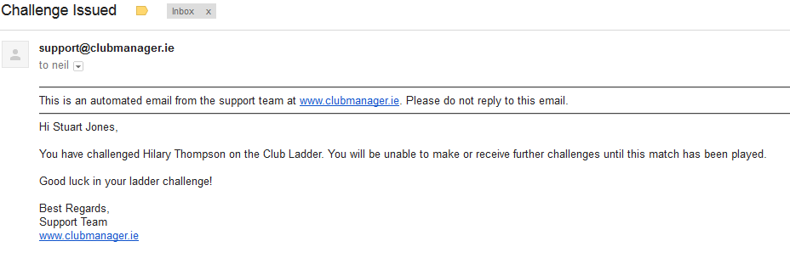

5.2 Enter a Challenge Result (Standard Singles Mode)
Locate your challenge on the right hand side of the ladders page:
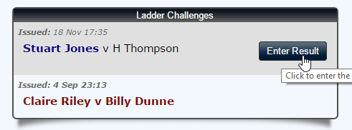
Click on “Enter Result” for the appropriate match. A form will pop out. Select the appropriate result and click submit:
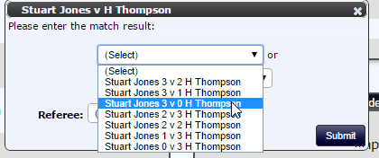
If the challenger has won, they will move up the ladder. As per the example in section 4.1, Stuart has moved up from 17th position to 14th position, displacing the players in between who each fall one place.
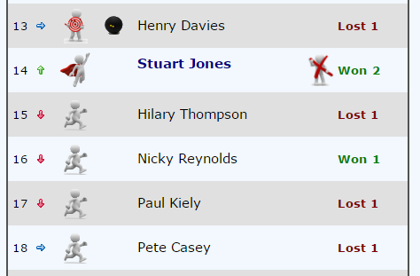

6 - Tournaments
Once logged in, user in clubs we provided challenge tournament services to will have the ability to view club tournaments which displays as a knockout. They can enter results for matches they are involved in, via the tournaments menu:
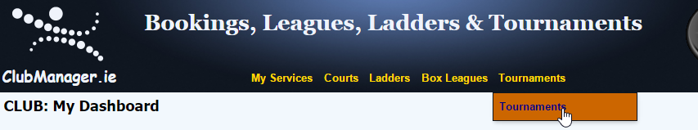

6.1 Entering a Result (Standard Singles Mode)
As the page loads, you have the option to select the tournament and section in the top left of the page. The tournament details are in the top right, and the knockout diagram showing the matches and results is in the centre of the page. The existing challenged and latest results are located on the right.
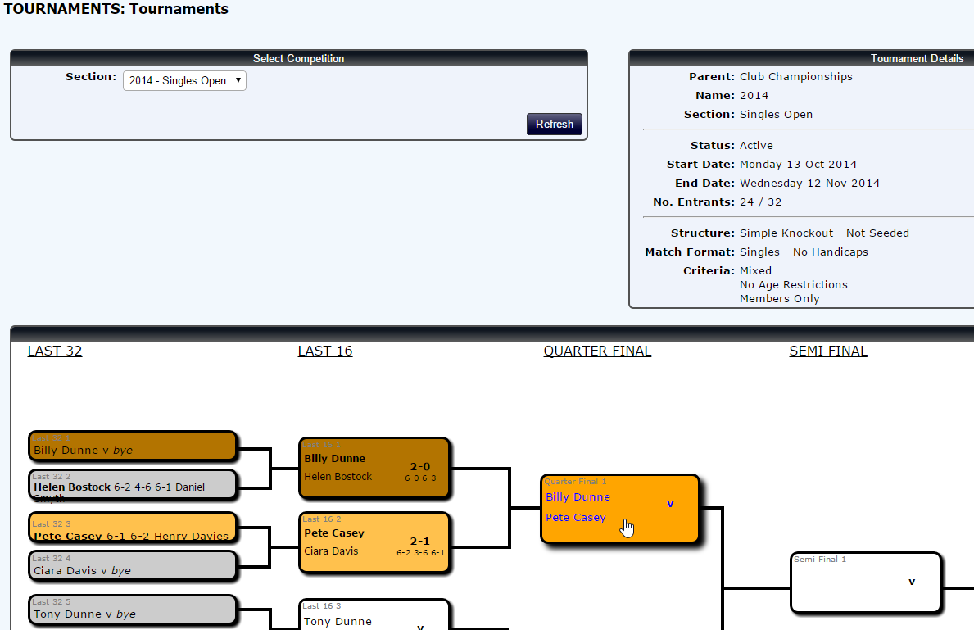
Click on the match you are taking part in. If result entry is permitted, a form will pop out. Select the appropriate result and click submit:

