User Guide for the CM365 Mobile App

1 - Background
Out App launched in 2019 provides some of the key and most frequently used functionality for users on devices, offering a faster and better user experience than our website. Please see the in-App FAQ for more details about our App.

2 - Installation

2.1 - Overview
Our app is a Progressive Web App (PWA). There is no need to visit the App stores as it can be installed on your phone or tablet straight from our website. Upgrades will be immediate as the installed App remains in sync with our latest version automatically.
This section outlines the process for somebody looking to find and install the App. In the near future we will add some additional prompting from our main website to help guide people.
At the end of this process, if done successfully, you will have the following icon available within the homepage(s) on your device. You will be able to click it to launch the app.

2.2 – iPhone / iPad Installation
1) Go to the following location using the internet browser on your device:
https://clubmanager365.com/CM365App/
2) This will load our app into your browser.
3) Click the icon at the bottom middle of the phone (circled below) in order to trigger the context menu. You will then see an option that says “Add To Homepage”, click this option to install the app.

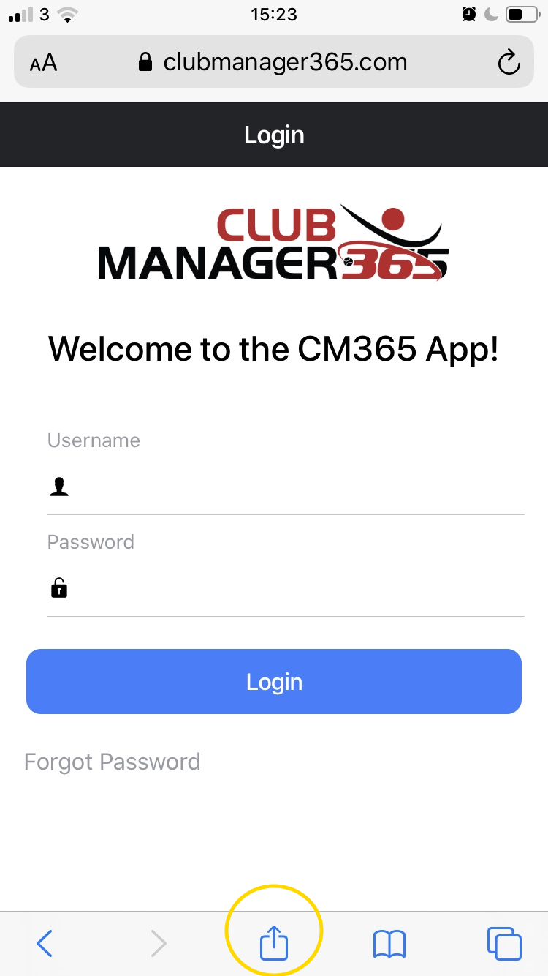
4) You will notice that our CM365 icon is on your phone. Any time you want to use the App you can launch it by clicking that icon
5) You will need to enter your username and password to gain access. You will be prompted to do this from time to time but in general you will be able to resume using the app without logging in again.

2.3 – Android Phone / Tablet Installation
As described above the App is a PWA available directly from our website, avoiding the need to visit the app store.
- Open an internet browser on your Android Device (e.g. Chrome for Android) and navigate to: https://clubmanager365.com/CM365App/

- A pop up icon will appear at the bottom of the screen “Add CM365App to Home screen”. Click this link, being careful to avoid the “X”.
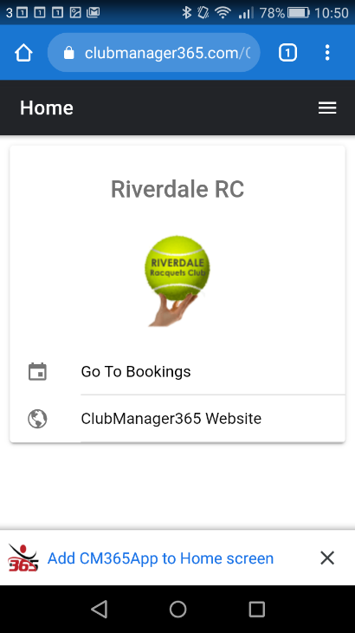

- You will be prompted to confirm, click the “Add” option

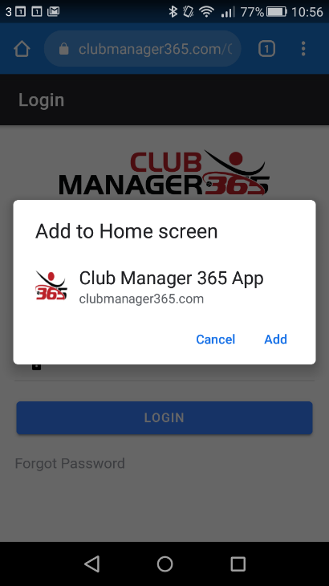

- The CM365 icon will now appear within your home screen(s) like any other app shortcut or widget. You can drag it around and put it wherever you like. Now simply click on the new icon to launch the application.

- You will need to enter your username and password to gain access. You will be prompted to do this from time to time but in general you will be able to resume using the app without logging in again.

Our App Login Page

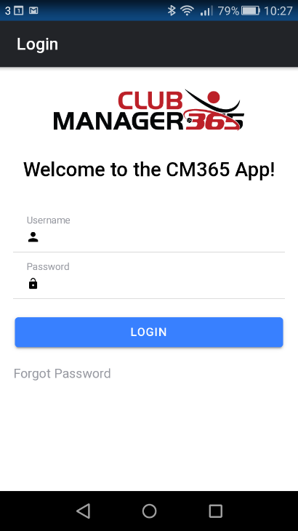

3 - Using the App

3.1 – Overview
The functionality within the app is divided in to the main areas of “Home”, “Bookings” and “Leagues” as denoted by the tabs at the bottom of the screen. Note that while Home is always available, visibility of other options are aligned to services subscribed to by your club. Ladders and Tournaments tabs will be added within the next 6-12 months.

3.2 – Home
The home page simply shows the club log and some convenience links. These are to bookings and leagues where the club has a relevant subscription, to a club website if one is configured, to the full clubmanager365 website and to this user guide and FAQ page.

In the top right there is a menu that can be used to sign out or change sport (for multi-sport clubs)

Changing Sport
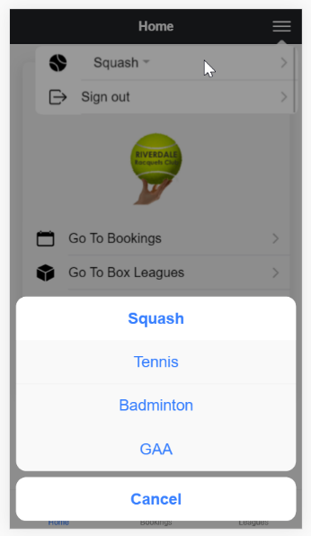

3.3 Bookings
The bookings section should be intuitive to use with familiarly named features and links. Below are some screenshots of what you might expect to see as you manage your bookings. You can make, edit and cancel bookings, action incoming match invites and view the rules. Each booking form is tailored to the clubs specific system so the options may vary slightly from the screenshots. Credits will only show when the club is using credits.

Bookings Landing Page and Options

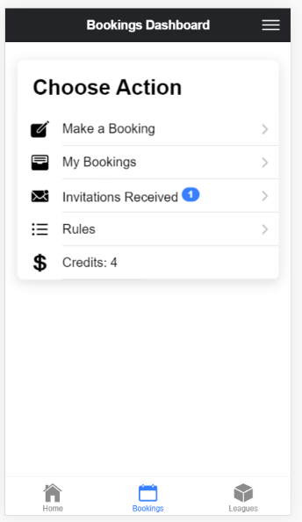

Making a Booking – Choose Date
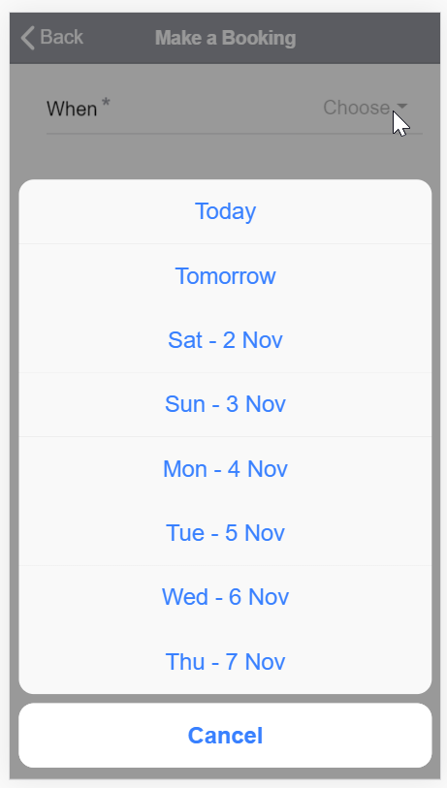

Making a Booking – Choose Slot

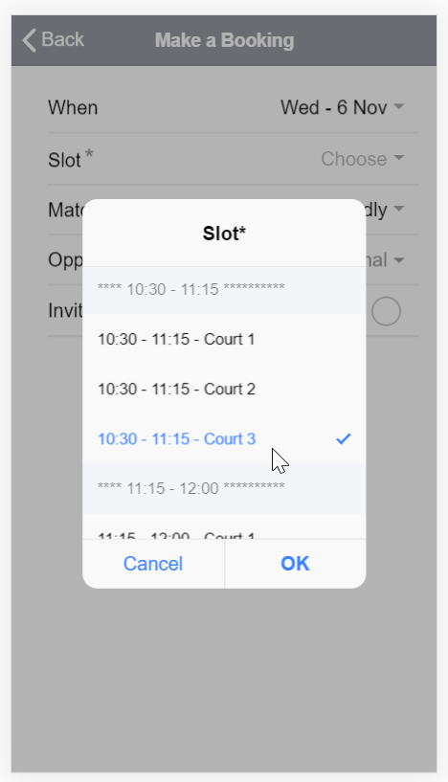

Making a Booking – Choose Opponents / Filter by Name

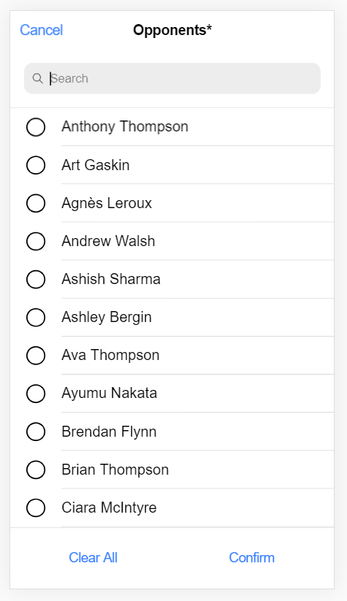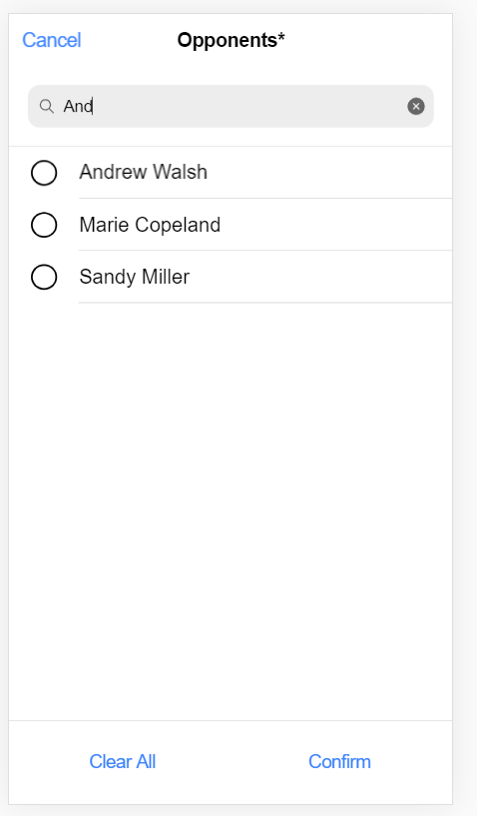

View Club Booking Rules

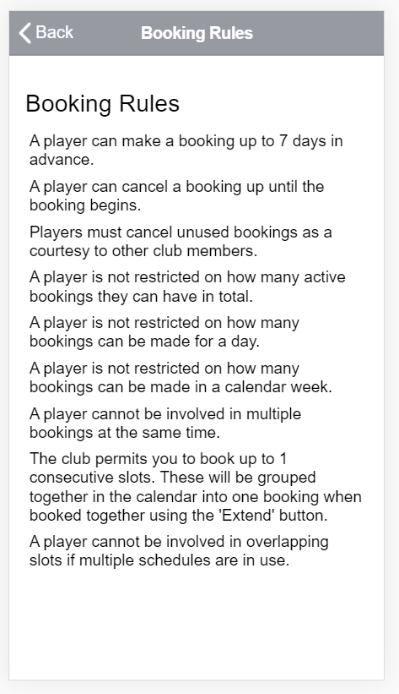

Review Bookings

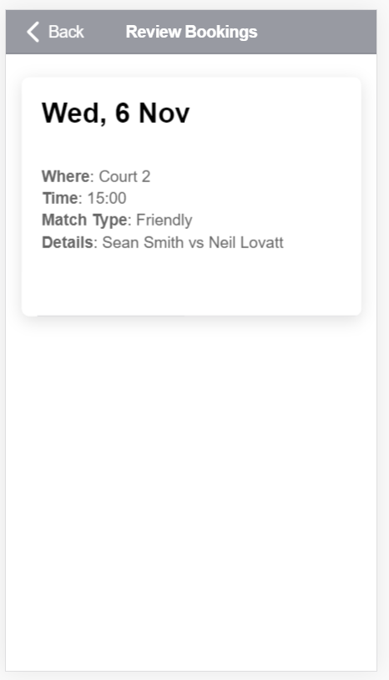

Cancelling - Click Cancel and Confirm

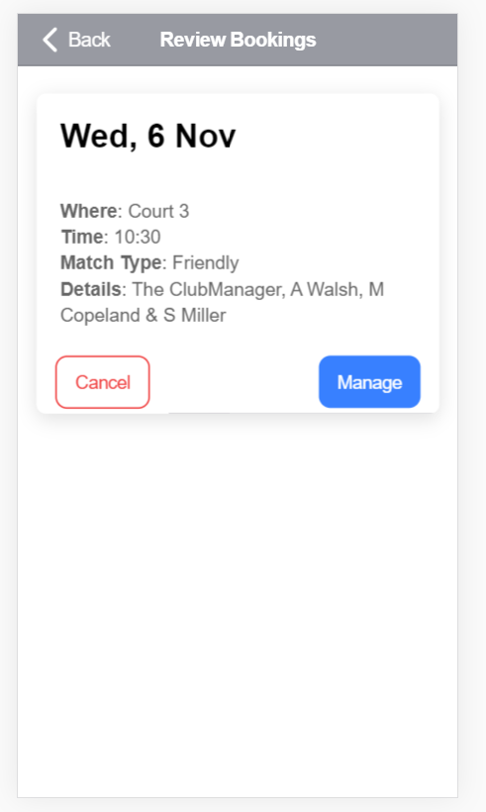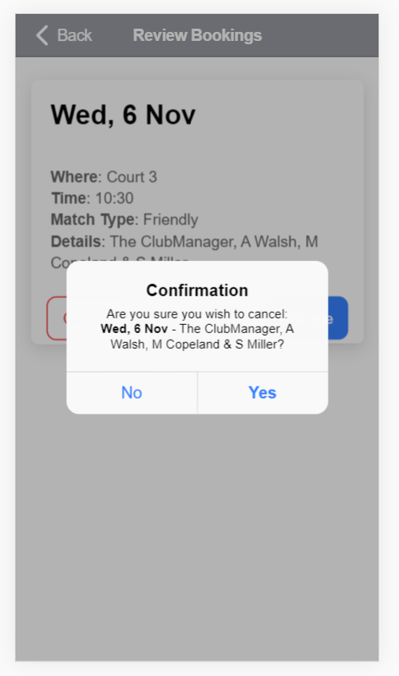

When You Receive an Invitation

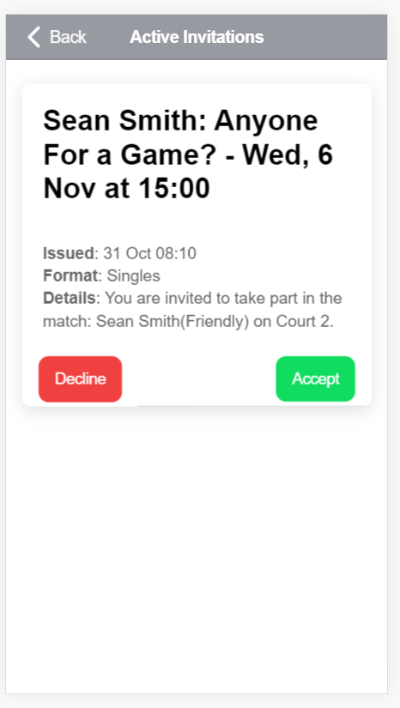

3.4 – Leagues
Below are some screenshots of what you might expect to see in our leagues section. Key functionality is dived into two views, positions and matches, with handy navigation to both and the ability to toggle between them. The menu icon that appears near the top right allows you to select different groups and boxes as well as view historical leagues. As pre our website, people can enter results for matches relevant to them, and administrators can enter and edit any match result.

Our Leagues Dashboard

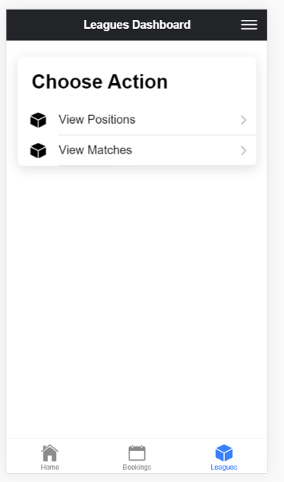

Viewing League Positions

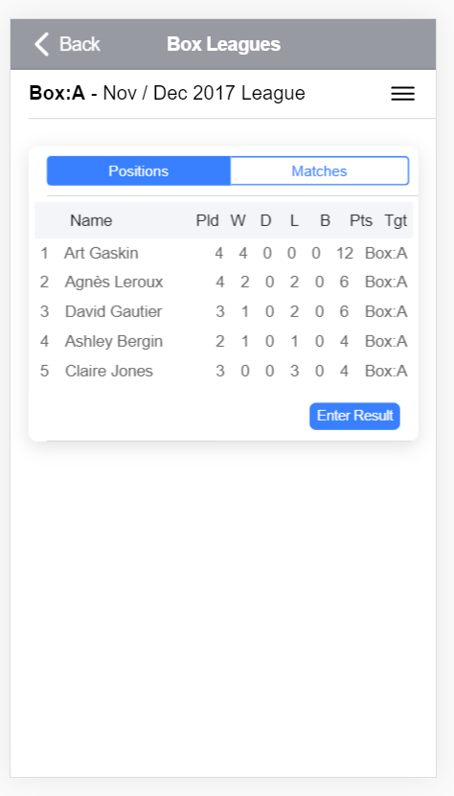

Changing Group, Box or League (menu top right)

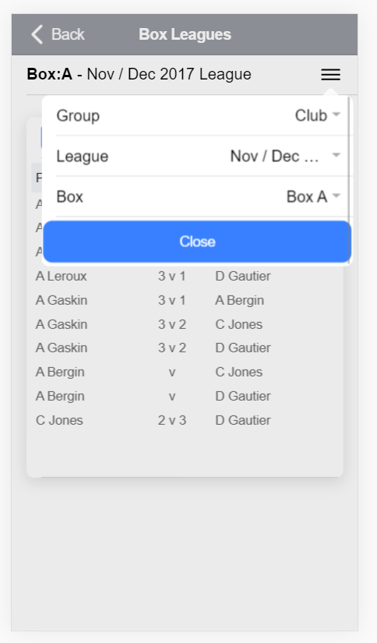

Viewing League Matches

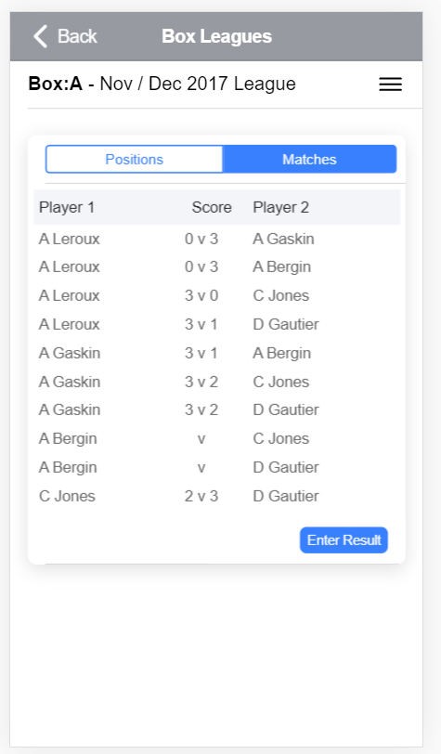
Entering a Match Result – Step 1 - Choose the Match

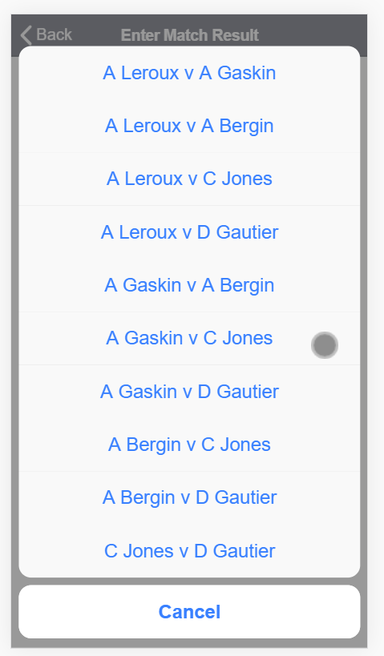

Entering a Match Result – Step 2 - Choose the Score

